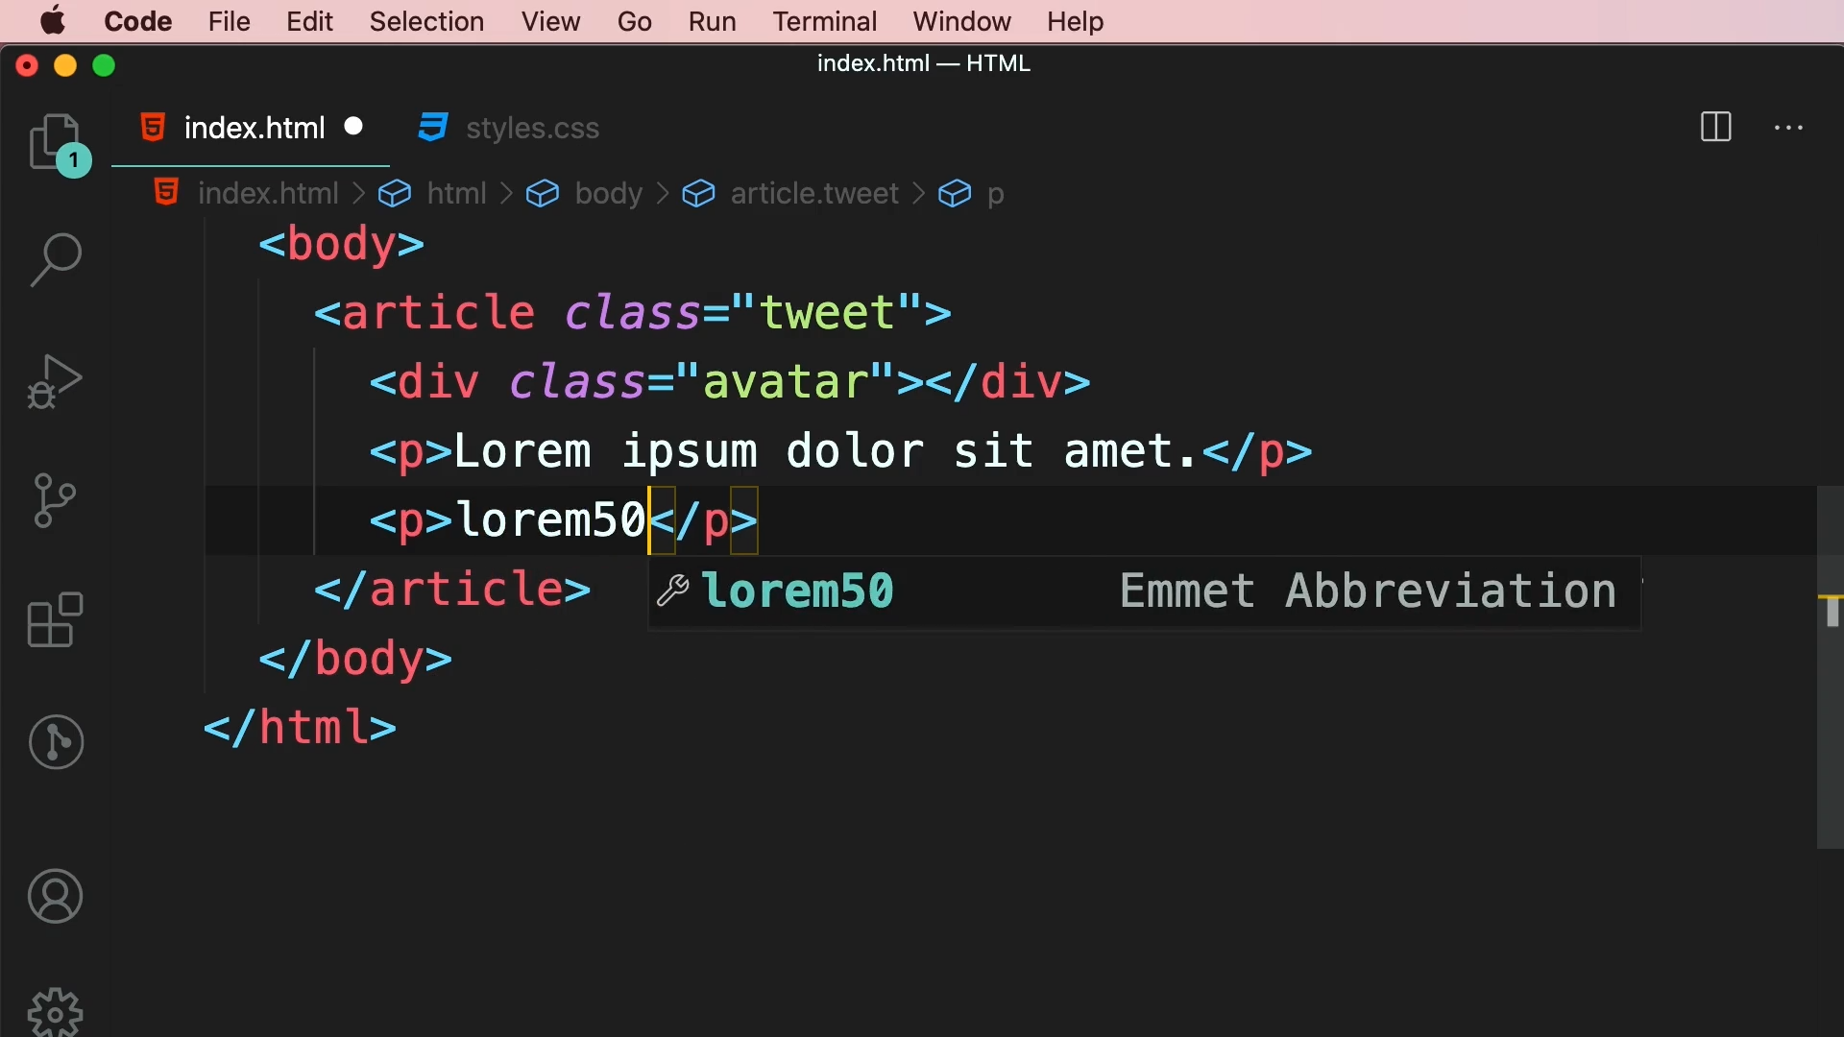

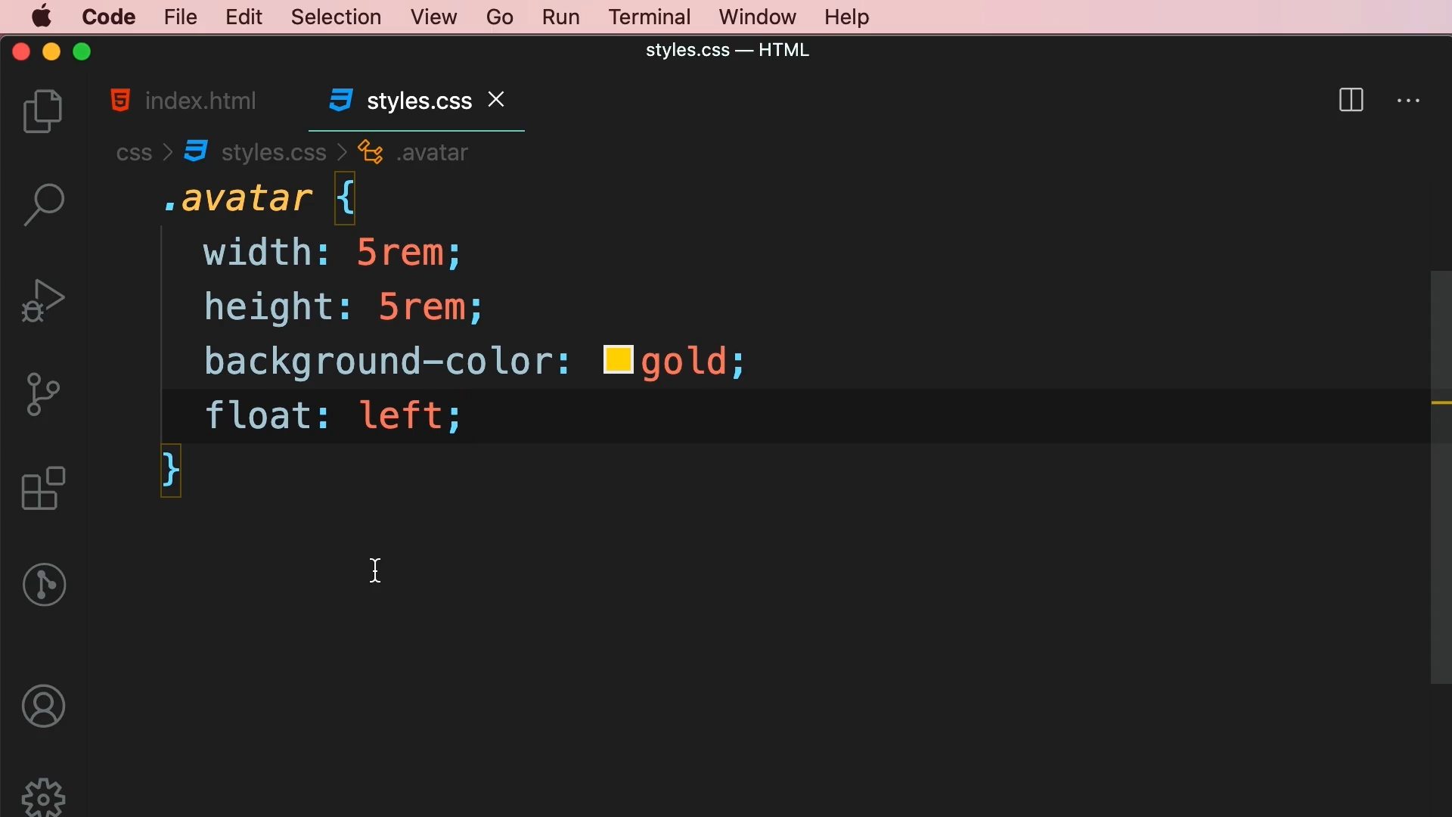

By default, paragraph is a block level element. Therefore, it will appear on new line. To put this paragraph next to avatar, we will use float property.

float: left;

This will make avatar element to float left side of its container and as a result of that all the subsequent elements will flow around it.

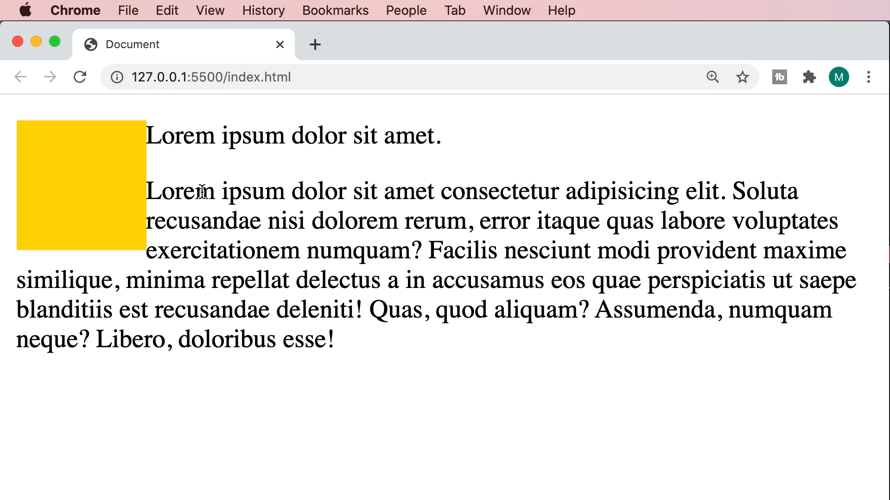

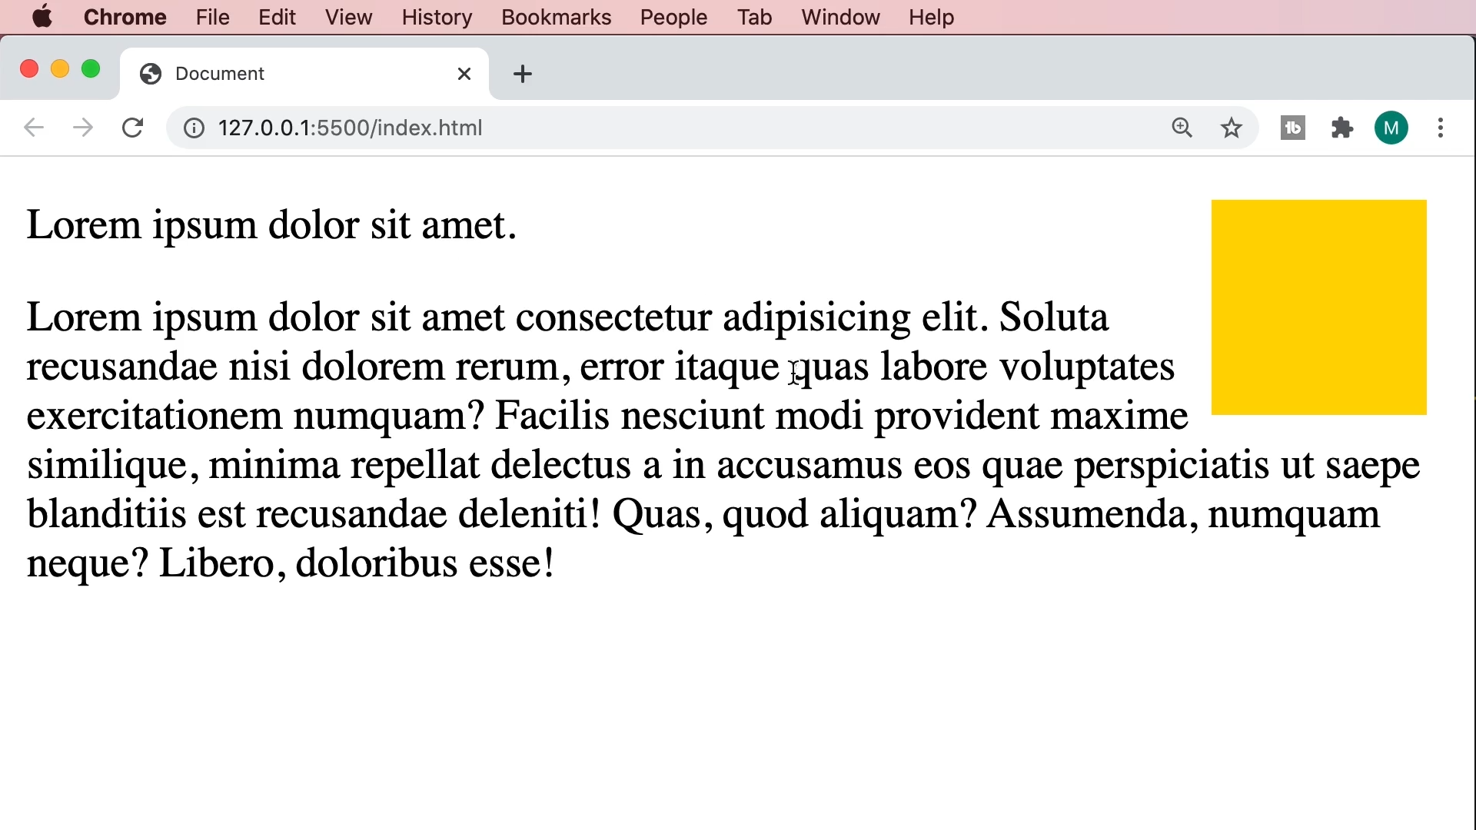

float: right;

Tailwind CSS

|  |  |
| --- | --- |
| Class | Properties |
| float-right | float: right; |
| float-left | float: left; |
| float-none | float: none; |